Exercise Sheet – Central Stability - Greyhound

Purposes;
- Develops trunk stability with low effort.
- Increases awareness of abdominal stabilisers

Step 1
- Lie on your back with your knees bent and feet flat on the floor. Take two deep breaths and relax your abdomen. Let your back soften and relax into the floor.

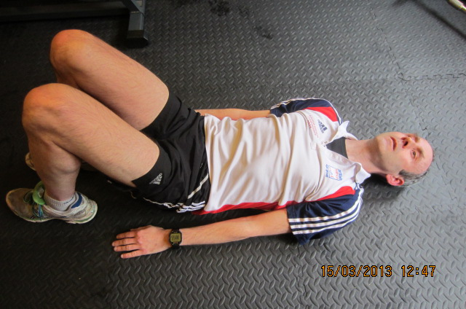

- Point both arms upwards towards the ceiling.
- Slowly move both arms over your head whilst at the same sliding one heel along the floor away from you and breathing out. Focus on lengthening your body by pointing your fingers and heel away from each other. Think “long and thin”.
- Bring your arms and leg back to the starting position with as little effort as possible. Repeat with the other leg.
- Perform 10 repetitions on each side or as prescribed.

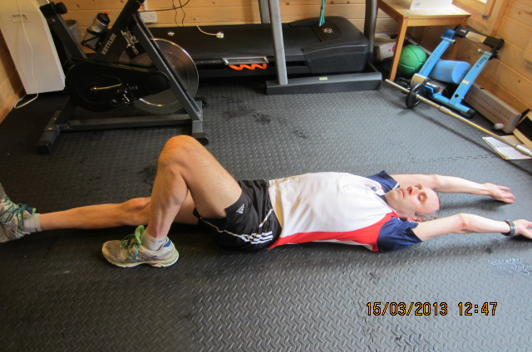

Step 2 – Greyhound with legs extending above the ground
- As Step 1 but extend leg 10cm above the ground
- Perform 10 repetitions on each side or as prescribed.

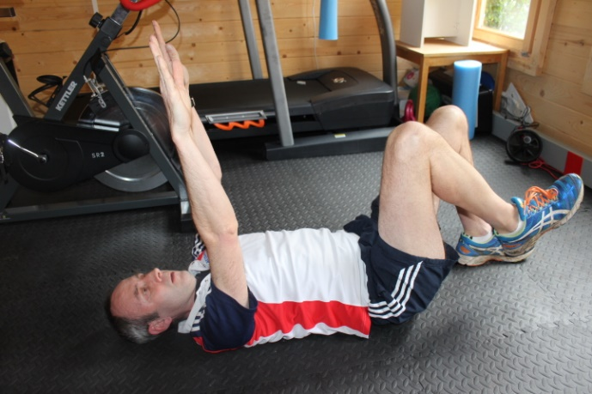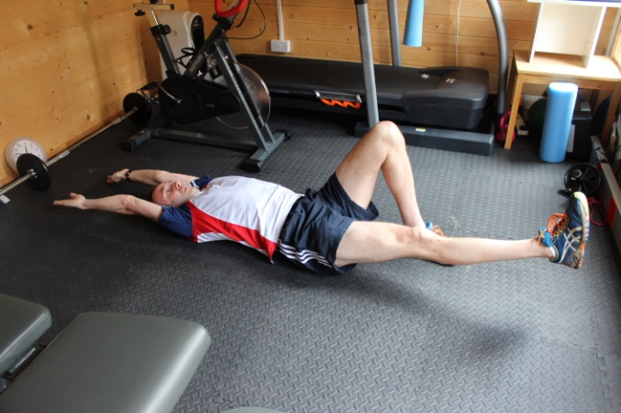

Step 3 – Greyhound starting with knees towards chest
- As above but starting position is with heels raised and knees towards your chest.
- The further away your knees are from your chest the harder this will be. Try to extend the legs/arms with the minimum of effort but keeping the back position constant.
- Breath out as you are pushing your heel away/pulling your arms over your head. Aim for six seconds breathing out.
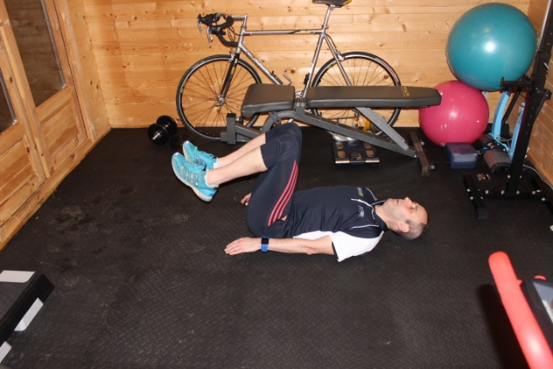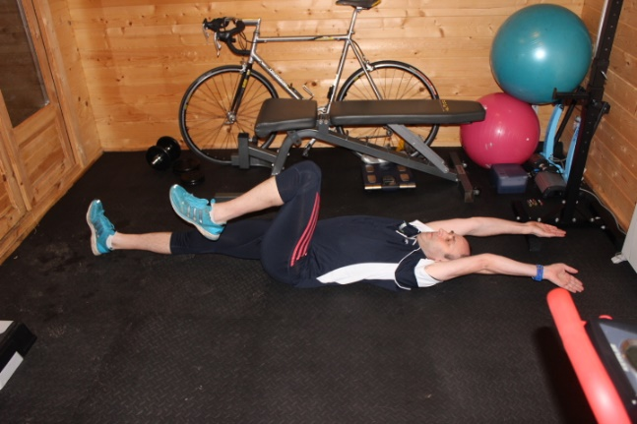

Step 4 – Leg lowering
- Start with legs raised straight up then lower one leg whilst breathing out.
- Ensure that back position stays constant.
