Exercise Sheet – Functional Mobility – Hip Mobility

Target area – Hip

Hip Flexion (Straight Leg)
- Lie on back, engage core by bringing belly button towards spine.
- Lift leg keeping it straight and making sure other leg is pushed into the ground.
- Ensure you maintain your lower back position.
- Perform 10 repetitions on each side or as prescribed.

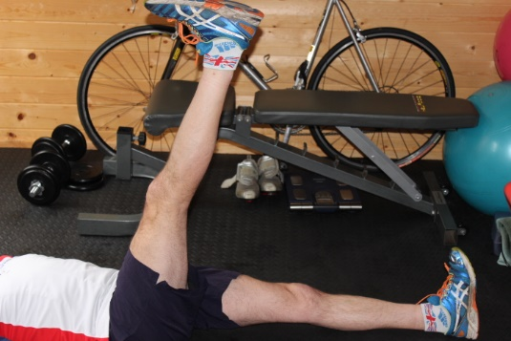

Hip Flexion (Knee Bent)
- As above but bring knee to chest

Hip Extension (Leg straight)
- Lie on your front, engage core by bringing belly button towards spine
- Slightly point foot out and lift leg to 10 degrees
- Don’t go further than 10 degrees
- Avoid using your back, the movement should come from your glutes

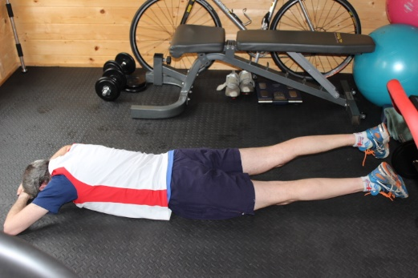

Hip Rotation (Knee bent)
- As above but bend knee and rotate lower leg from side to side

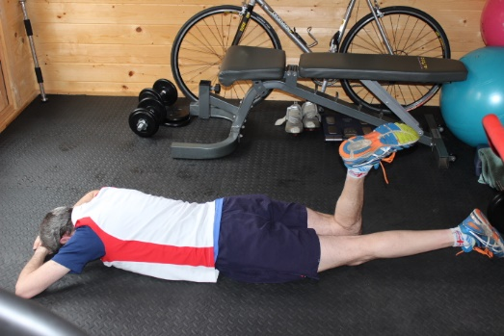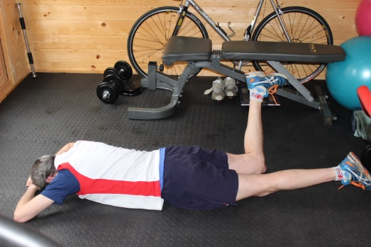

Standing leg swing
- Stand on one leg.
- Stand tall and swing the other leg fully backwards and forwards, allowing your arms to move normally.
- Keep your trunk vertical and leg swinging in a straight line.
- Keep pelvis level.

