Exercise Sheet – Lower Strength (hip dominant single leg) – Knee raise/hip extension

Purposes;
- Activates key muscles for running, particularly the glutes
- Movement pattern for hip extension, raising hip on swing leg and resisting rotation
- Enhances balance and proprioception.

Stage 1 – knee raise/hip extension
- Stand on one leg and raise the other leg to 90 degrees.
- Drive leg backwards behind stance leg whilst keeping body straight.
- Ensure body stays straight.

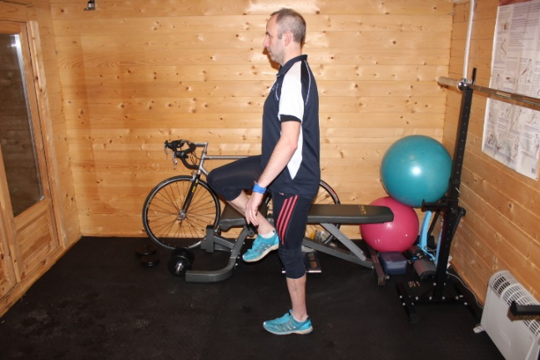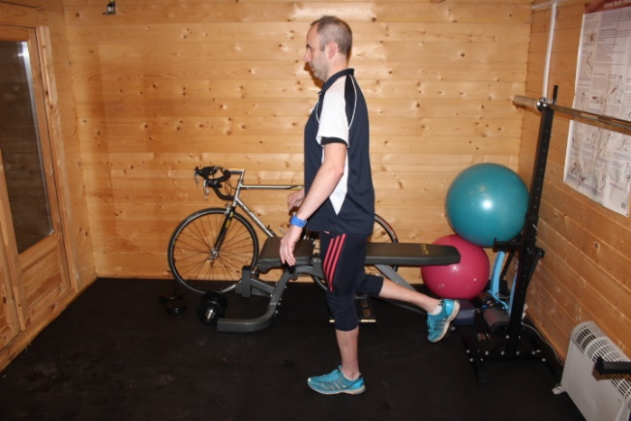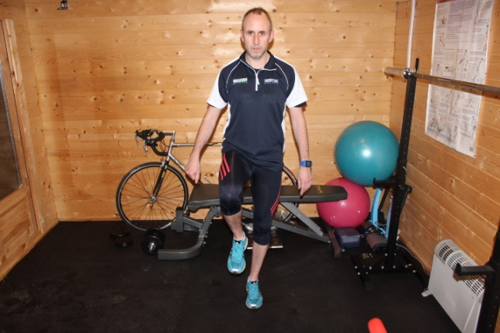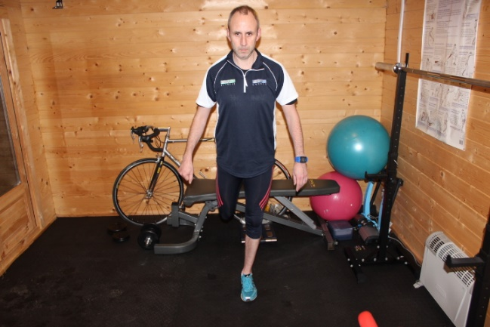

Stage 2 – raise up onto toes on stance legs
- Raise up onto toes on stance leg keeping body straight and “tall”

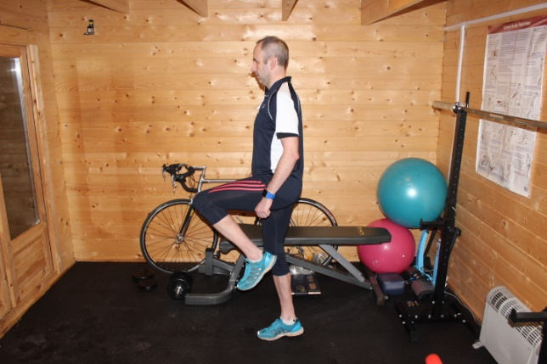

Stage 3 – upper body rotation

- Rotate upper body to the side
- Keep knee facing forward

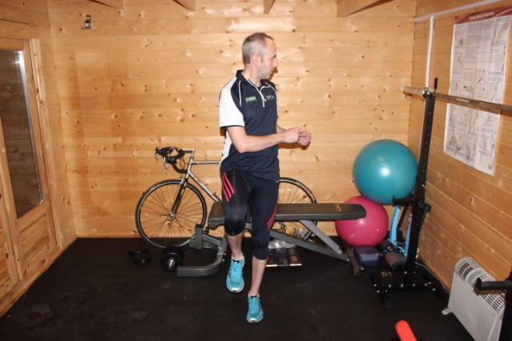

Stage 4 – hip rotation

- Rotate raised leg to the side
- Keep upper body facing forward

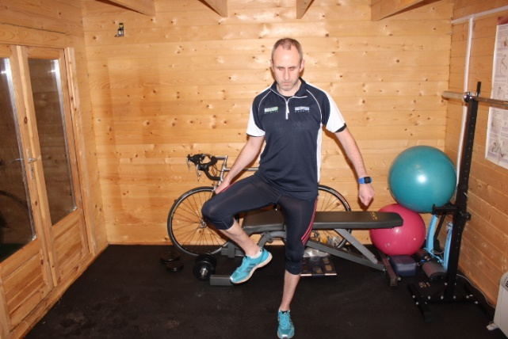

Stage 5 – stick drill

- Repeat knee raise/hip extension from stage 1 holding a stick above your head
- The aim is to keep as tall as possible without “falling over” to the side
- This can be progressed to a walking, skipping and running drill

