Exercise Sheet – Functional Mobility – Ankle Mobility

Target area – Ankle

Sagittal Plane (Backwards and Forwards)
- Place front foot around five inches from a wall, back foot behind. Both feet should face forwards.
- Rock ankle backwards and forwards so that knee comes towards the wall.
- Ensure both heels stay on the floor and remain facing forwards.
- Perform 10 repetitions on each side or as prescribed.

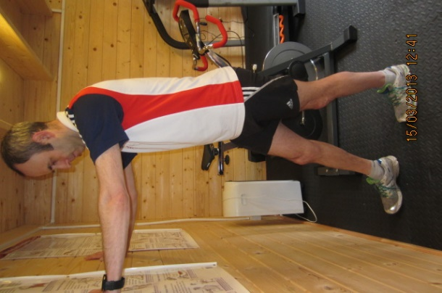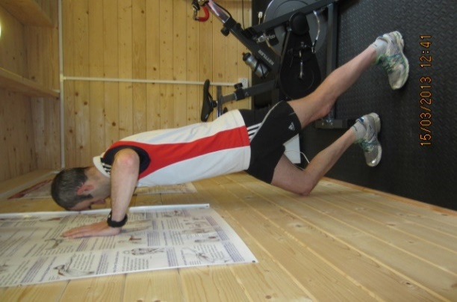

Frontal Plane (Sideways)
- Stand arm’s length away from the wall.
- Swing each leg away from the body whilst keeping the trunk upright and back straight. Return to midline
- Aim to maintain foot contact with the floor without twisting sideways.
- Perform 10 repetitions on each side or as prescribed.

