Exercise Sheet – Upper Mobility – Side Lying Windmills

Purposes;
- To increase thoracic spine mobility.
- Increases awareness of the scapula.

Stage 1 – scapula awareness.
- Lie on your side with your top leg supported and your arms out in front of you.
- Slowly and smoothly slide your top hand forward over your bottom hand. Feel for the movement from your shoulder blade which you should feel move around your rib cage. Keep the movement relaxed and aim to eliminate any tension, particularly in the neck or the front of the shoulder.
- Repeat until comfortable and relaxed.

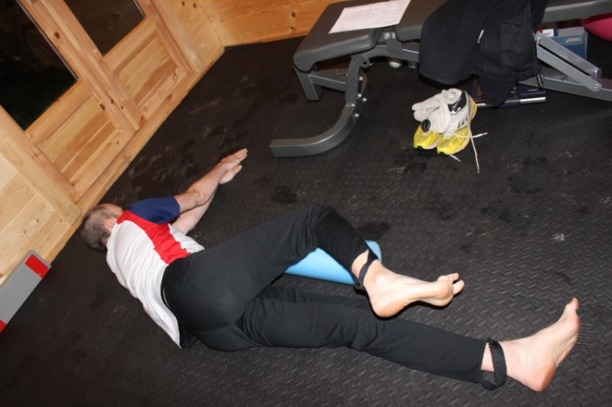

Stage 2 – Side-Lying Windmill
- From the position in stage 1 straighten your body then move your top arm round the top of your head to the back of your body, following the motion of your hand with your eyes.
- Aim for the majority of the movement to be from the upper rather than the lower back.
- Perform 10 repetitions each side or as prescribed.

