Exercise Sheet – Central Stability – Box Hip Extension with Dowell/Superman

Purposes;
- Improve abdominal muscle performance
- Improve control of the spine in preventing rotation
- Improve balance control
- Improve control of the pelvis

Step 1
- Starting position on hands and knees with feet pointing away from body, hips a few inches apart and positioned over the knees which should be a few inches apart. Hips at a 90 degree angle, shoulders positioned over hands and head in line with the body. Balance dowel along back and between buttocks

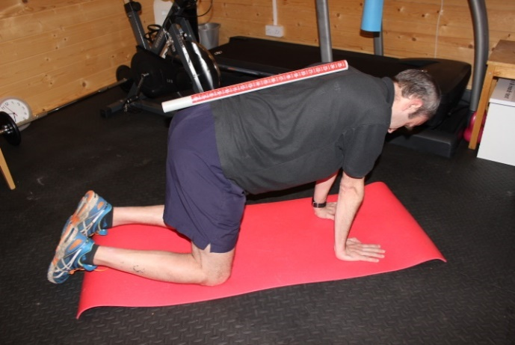

- Contract your abdominal muscles by “pulling your belly button towards your spine” whilst breathing out, then breathe normally through the exercise.
- Keep your knee bent and lift your leg at the hip backwards.
- Do not let your pelvis or spine move
- Hold position for 5 seconds
- Return to the starting position
- Repeat with alternate leg
- Perform 10 repetitions on each leg or as prescribed

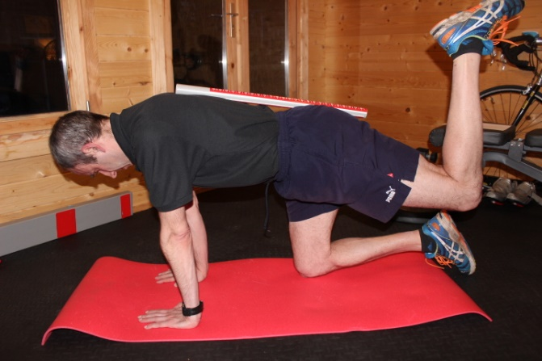

Step 2
- As above but straighten your leg pushing out with the heel.

Step 3 – Superman
- As above but lift your opposite arm at the same time as straightening your leg. Stretch out with your fingertips and heel so that you have a straight line from fingers to heel. Your chest and pelvis should be parallel to the floor.
- Repeat with your opposite arm and leg.
- Perform 10 repetitions on each leg or as prescribed

