Exercise Sheet – Central Stability – Bridge Level 1

Purposes;
- Restore mobility between the spine and the pelvis
- Loosen tight back muscles
- Engage the hip extensors, in particular Gluteus Maximus, in the hip straightening movement pattern

Step 1
- Lie on your back with your knees bent and feet on the floor with heels down. Keep your feet close to your body.

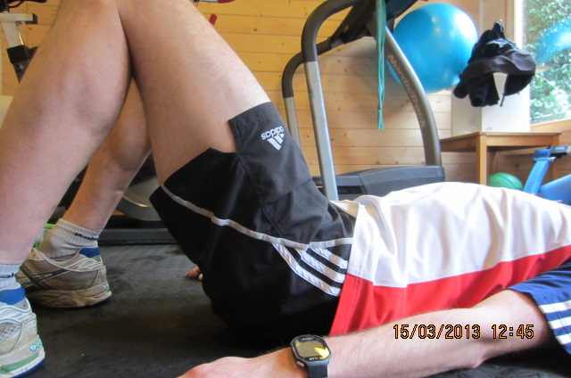

- Relax your abdominals and roll your pelvis towards you, pressing through your heels so your bottom comes off the ground.
- Your back should stay relaxed.
- You may feel a stretch in your quadriceps due to rolling your pelvis towards you.

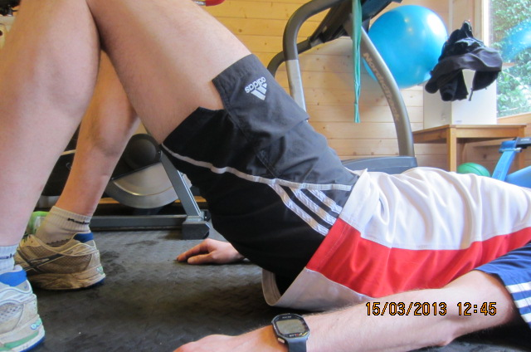

Step 2 – feet elevated
- As step 1 but elevate feet on a step.

