Exercise Sheet – Central Stability – Front & Side Plank

Purposes;
- Improves strength of anterior and lateral abdominal muscles.

Front Plank
- Begin kneeling on all fours.
- Draw in your belly button towards your spine and lock your arms fully. Straighten first one then the other leg taking the weight on the balls of your feet.
- Hold the position for 10 seconds.
- You should maintain a straight line through your feet, knees, hips and shoulders.
- Breathe normally through the exercise, do not hold your breath.
- Perform 10 repetitions or as prescribed

Front Plank with leg raise
- As above but raise one leg slightly for 10 seconds, then repeat with the other leg

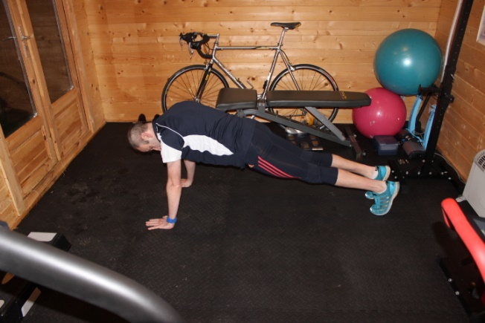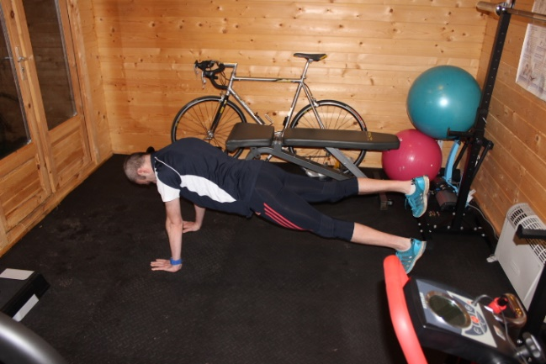

Side Plank

- Lie on your side with your feet together and your body in a straight line.
- Press up on elbow, creating a straight body line. Make sure your hips are straight.
- Breathe normally through the exercise.
- Progress to pressing up onto one hand rather than an elbow.
- Hold for 10 seconds and perform 10 repetitions, or as prescribed.

