Exercise Sheet – Lower Strength (hip dominant single leg) – Single leg deadlift

Purposes;
- Develops the entire posterior chain.
- Strengthens glute medius and hip stabilisers
- Enhances balance and proprioception.

Stage 1 – hip hinge from a staggered stance
- Start from a staggered stance with a weight in the same arm as the “back” leg
- Hip hinge keeping the back straight

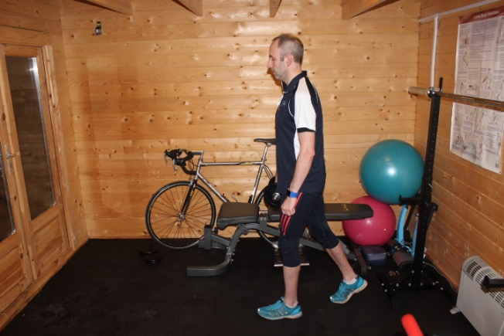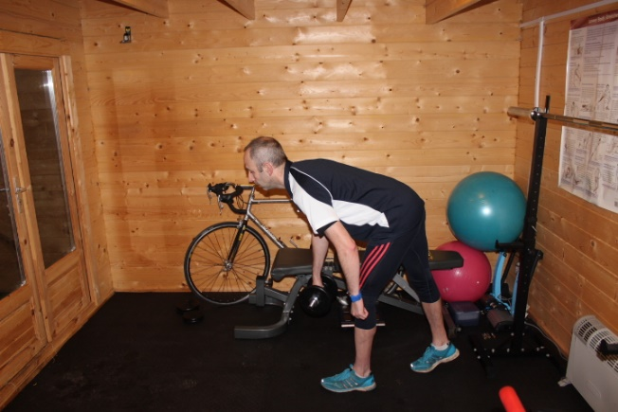

- Progress by moving the rear leg back further and taking a step forward at the end of each repetition

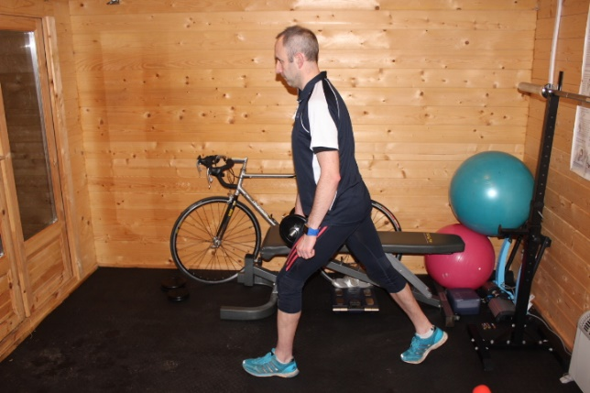

Stage 2 – hip hinge with back leg supported

- Start exercise above with rear leg supported. This helps to keep the hips level.

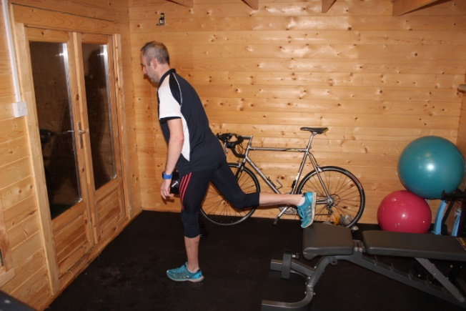

- Progress by using a valside (sliding support) for the rear leg and slide the leg backwards whilst doing the hip hinge.

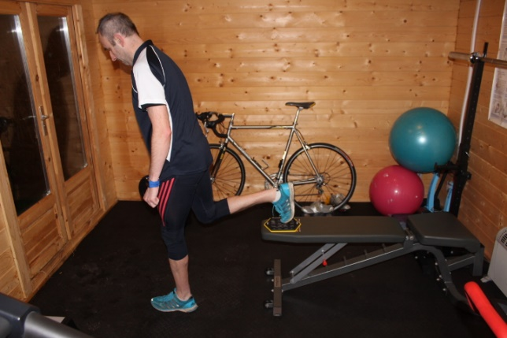

Stage 3 – single leg deadlift

- Rear leg is now unsupported. Drive leg backwards to initiate the movement and then bend forward from the hips
- Aim to keep the hips level and avoid twisting in the upper body.

